|  |  |
| --- | --- |
| **Nikon AF-S 24-70mm f 2.8E ED VR Nano Lens**  Ống kính Nikon AF-S 24-70mm f/2.8E ED VR Nano  Nikon AF-S 24-70mm f2.8E ED VR Nano 1 Nikon AF-S 24-70mm f2.8E ED VR Nano 3 Nikon AF-S 24-70mm f2.8E ED VR Nano 5 Nikon AF-S 24-70mm f2.8E ED VR Nano 4 | **Featured information:**   * Format: Nikon F-Mount / FX * Aperture: f/2.8 - f/22 * Nano Crystal & Super Integrated Coating * ED glass element is aspherical   Price : 1500$  **Specifications:**   * **Focal distance:** 24 - 70mm * **Largest Aperture:** f/2.8 * **Smallest Aperture:** f/22 * **Lens Mount:** Nikon F * **Lens Format:** Full-Frame * **View:** 84° - 34°20' * **Minimum Focus Distance:** 38 cm * **Magnification:** 0.27x * **Optical Components:** 20 Elements in 16 Groups * **Number of Mouth Blades:** 9 * **Focus Type:** Auto focus * **Anti-Vibration:** Yes * **Filter Size:** 82 mm (Front) * **Size:** 88 x 154.5 mm * **Weight:** 1070 g |

**Description:**

**Lens Design**

The Nikon AF-S 24-70mm f/2.8E ED VR is a versatile wide-angle to short-angle telephoto lens characterized by a constant f/2.8 maximum aperture and electromagnetic aperture mechanism. Designed for use with FX-format Nikon F-mount cameras, the lens is also compatible with DX models, providing a 36-105mm equivalent focal length range. The fluorine coating on the front and rear parts is resistant to dust and moisture suitable for working in harsh environments.

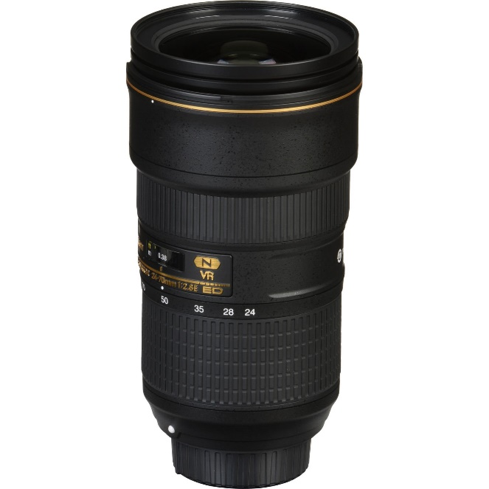

Vibration reduction image stabilization reduces the appearance of camera shake by up to four stops to maximize shooting in a variety of lighting conditions.

